Crop Type Mapping using Convolutional Neural Network from Satellite images.

1. Background and Motivation
Agriculture is an important sector for food security and economic development. Crop typing is helpful for crop monitoring, yield estimation and efficient resource management by governments, farmers and researchers. Conventional field surveys take a long time and are costly. The satellite imagery and machine learning is an effective solution for large-scale crop monitoring.
Recent development in deep learning with Convolutional Neural Networks (CNNs) has enabled a great classifcation capability in images. The goal of this project is to automatically classify satellite images and land cover categories from the EuroSAT dataset with the help of CNN based models.

2. Problem Statement
Manual crop mapping is labor-intensive, and often not possible in large geographical areas. This project aims to build an image classification model based on CNN to automatically classify the crop and land-cover classes from satellite images.
The project will be used to assess the performance of CNN models and transfer learning for satellite image classification.

3. Dataset Information
Dataset Name
EuroSAT Dataset
Dataset Source
https://www.kaggle.com/datasets/apollo2506/eurosat-dataset
Dataset Description
The EuroSAT dataset comprises of 10 classes of Sentinel-2 satellite images. The images depict a variety of different surface types, such as agricultural areas, forests, water bodies, and urban areas.
Number of Images
27,000 images
Number of Classes
10 Classes
1. AnnualCrop
2. Forest
3. HerbaceousVegetation
4. Highway
5. Industrial
6. Pasture
7. PermanentCrop
8. Residential
9. River
10. SeaLake

Image Type
RGB Satellite Images
Class Distribution
The data set is relatively well balanced with about 2000-3000 images per class.

4. Research Questions
RQ1:How well can CNN models classify satellite images into various crop and land cover classes?

RQ2: What are the most well-trained CNN models for which classes?

RQ3: Can transfer learning benefit the classification accuracy over a customized CNN model?

RQ4: What are the most important features of the image for classification accuracy?

5. Results

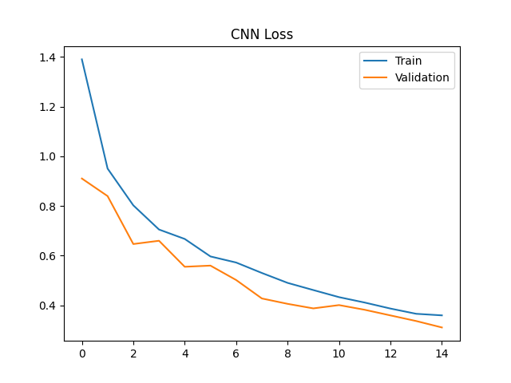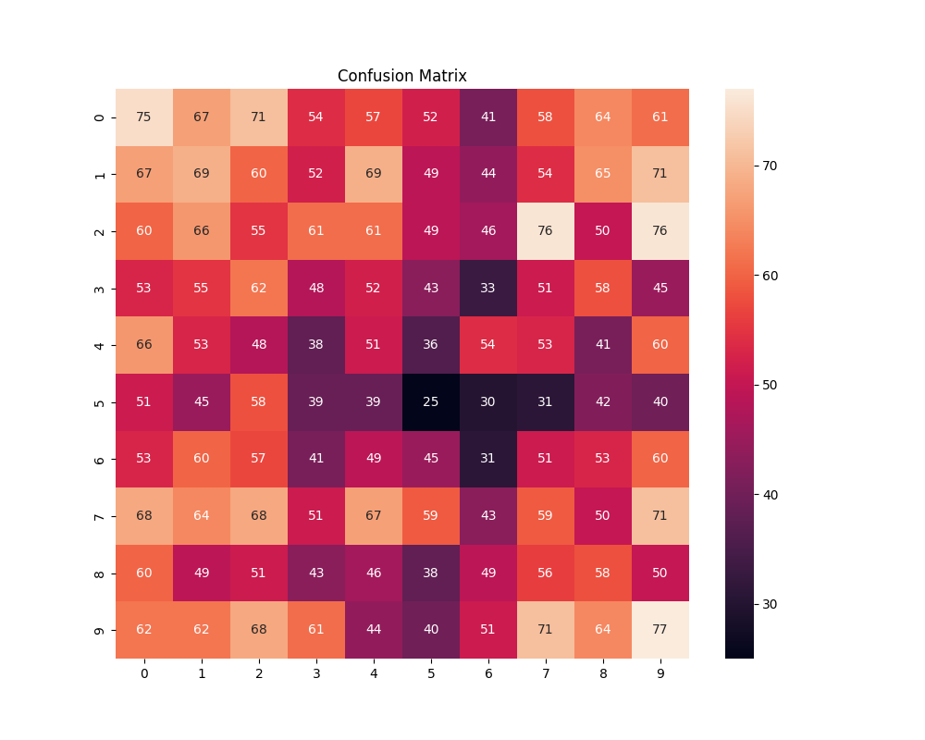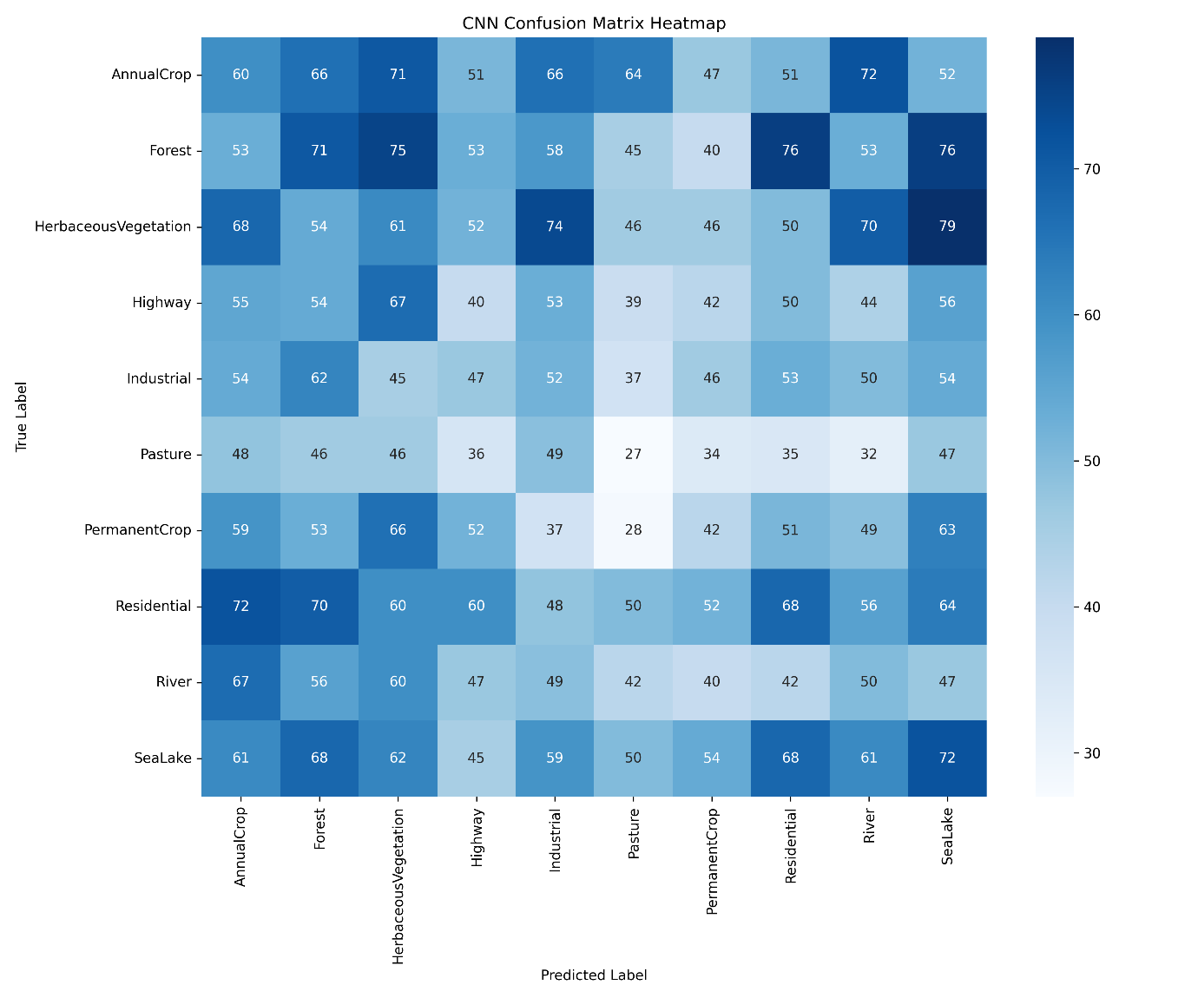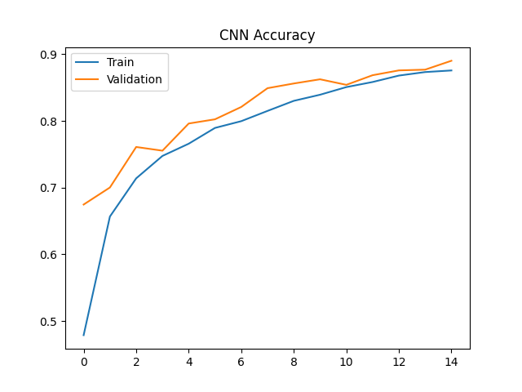

6. Proposed Methodology
Step 1: Dataset Loading
Load the EuroSAT satellite images.
Step 2: Data Preprocessing
* Image resizing
* Image normalization
* Data cleaning
* Label encoding
Step 3: Train/Test/Validation Split
* Training Set: 70%
* Validation Set: 15%
* Test Set: 15%
Step 4: Data Augmentation
Apply:
* Rotation
* Horizontal Flip
* Zoom
* Brightness Adjustment
Step 5: CNN Model Development
Create your own CNN model that arranges the following:
* Convolution Layers
* ReLU Activation
* Max Pooling Layers
* Fully Connected Layers
* Softmax Output Layer
Step 6: Transfer Learning
Compare performance with MobileNetV2 (pre-trained feature extraction), and compare with custom CNN.
Step 7: Model Evaluation
Evaluate performance using:
* Accuracy
* Precision
* Recall
* F1-Score
* Confusion Matrix
Step 8: Visualization
Generate:
* Accuracy Curves
* Loss Curves
* Confusion Matrix
* ROC Curves
* Sample Predictions

7. CNN Model Design
Input Layer (64 × 64 × 3)

↓

Conv2D (32 Filters)

↓

MaxPooling

↓

Conv2D (64 Filters)

↓

MaxPooling

↓

Conv2D (128 Filters)

↓

MaxPooling

↓

Flatten

↓

Dense (128 Units)

↓

Dropout

↓

Output Layer (10 Classes)

8. Transfer Learning Model
Model: MobileNetV2
Advantages:
* Faster training
* Better feature extraction
* Higher classification accuracy
* Reduced overfitting

9. Evaluation Metrics
The following evaluation metrics will be used:
* Accuracy
* Precision
* Recall
* F1-Score
* Confusion Matrix
* ROC-AUC
* Classification Report

10. Tools and Technologies
Programming Language:
Python
Libraries:
* TensorFlow
* Keras
* NumPy
* Pandas
* Matplotlib
* Seaborn
* Scikit-learn

Development Environment:
* Kaggle Notebook
* GitHub

11. Conclusion
The crop type mapping and satellite image classification using the EuroSAT dataset is proposed in this project, based on a CNN framework. The research will be based on comparing a custom CNN with a transfer learning method, and will use several performance metrics to assess their performance. The outcome is expected to show the applicability of deep learning methods in automation of agricultural monitoring and land-cover classification.

